Tasks

* Use the docker run command to start a new container and interact with it through the command line. [Hint: docker run hello-world]

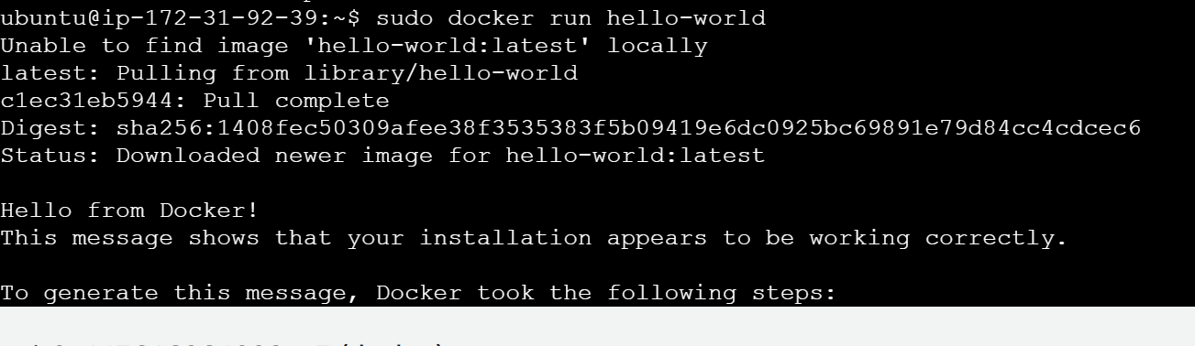

* Use the docker inspect command to view detailed information about a container or image.

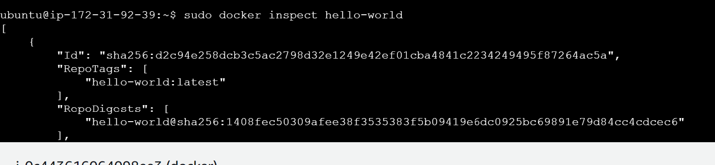

* Use the docker port command to list the port mappings for a container.

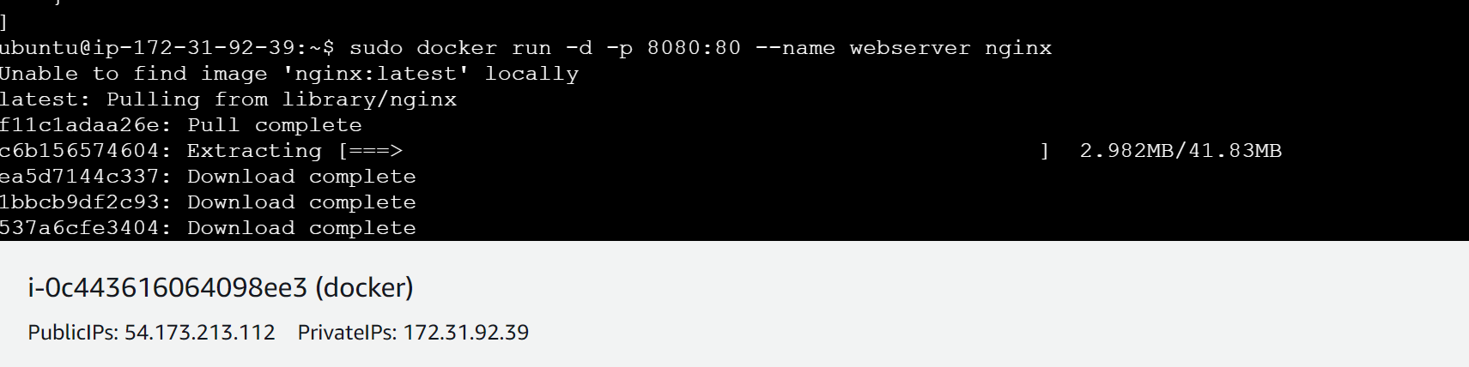

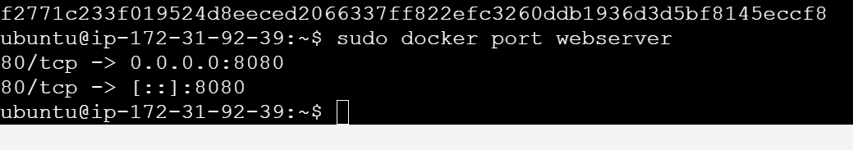

* Use the docker stats command to view resource usage statistics for one or more containers.

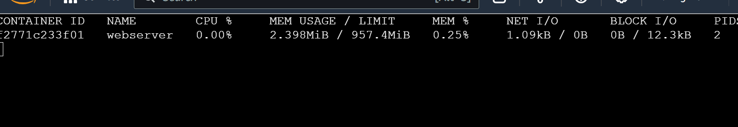

* Use the docker top command to view the processes running inside a container.

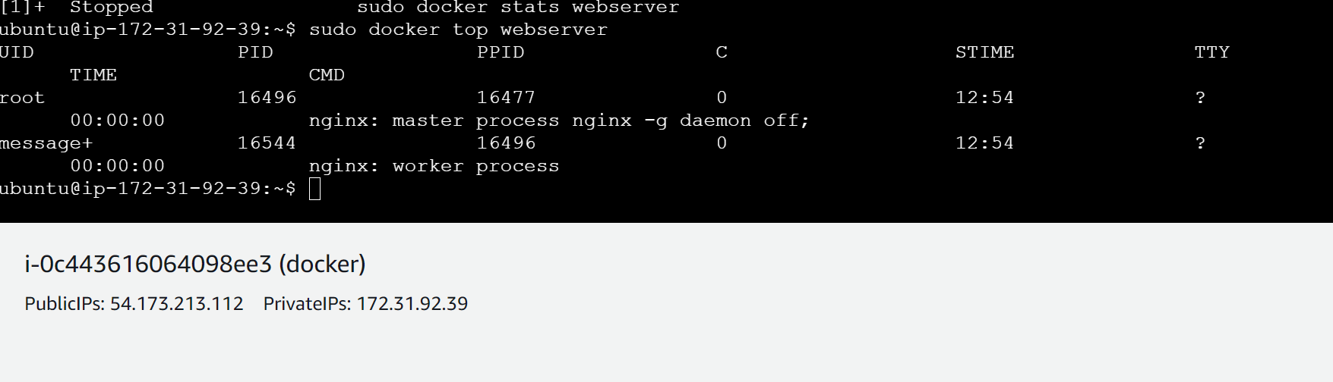

* Use the docker save command to save an image to a tar archive.
* Use the docker load command to load an image from a tar archive.

